# **Lab Exercise 2- Data Lake & Data Model (Mapping & Design)**

### 

### **Objective**

By the end of this hands-on, you will:

* Understand how Data Lake Objects (DLOs) map to Data Model Objects (DMOs).
* Create and map a formula field to enrich your dataset.
* Navigate to Data Model and Map Data.
* Visualize your model in graph view and verify relationships before unification.
* Use Data Model to validate mapped data.

## **Part 1: Add & Map a Formula Field**

1. **Open Your Data Stream**

Go to **App Launcher → Data Cloud → Data Streams**.

Select an existing data stream you ingested in Module 2 (e.g., Contact_Home).

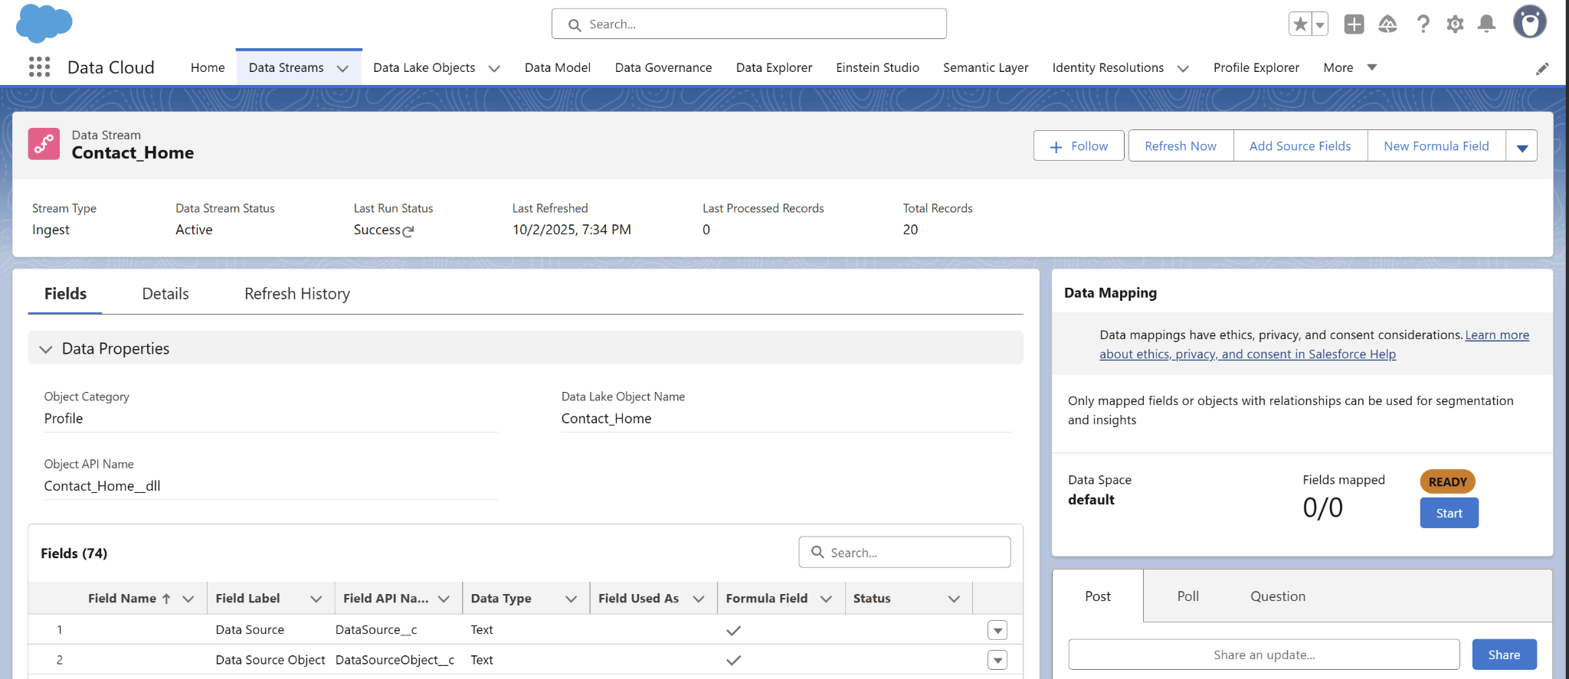

1. **Add a Formula Field**
   * In the stream detail, click **Fields → Add Formula Field**.

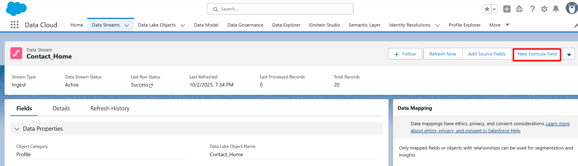

* + Define a new formula field:
    - **Name:** CompositeContactKey
    - **Type:** Text
    - **Formula:** CONCAT(Email, “-”, MobilePhone)  
       (This creates a composite key for unique identification.)

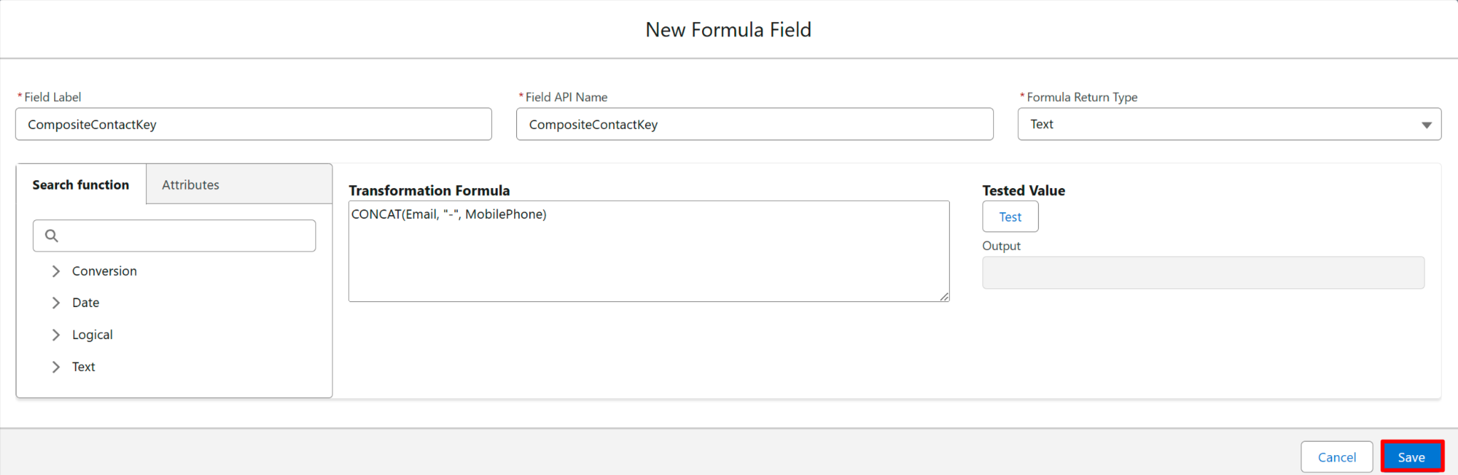

* + **Map the Formula Field**The mapping interface opens. On the right side, under **Data Model entities**, expand the **Profile** subject area.

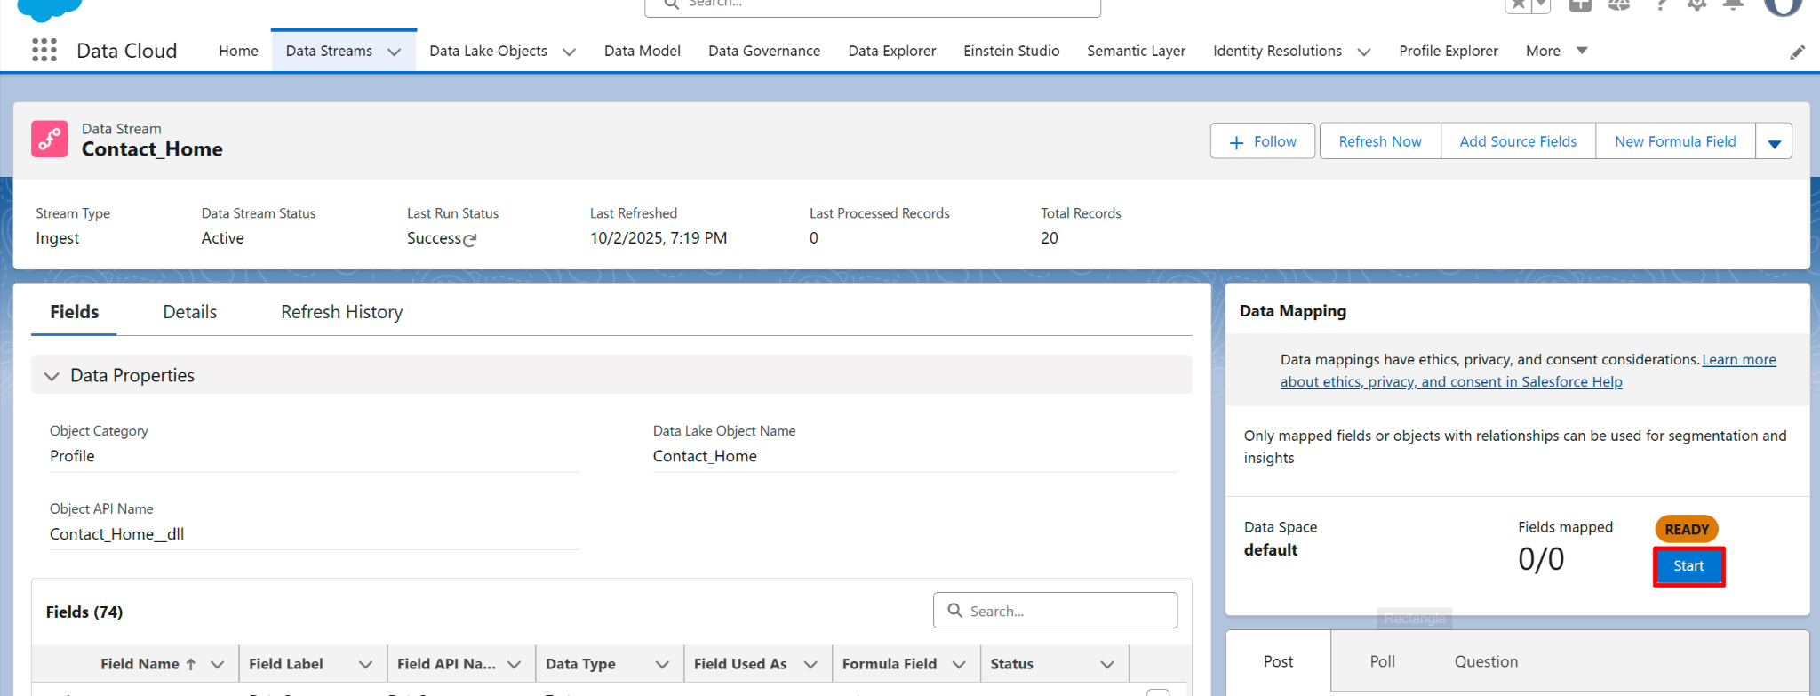

Click the **+** button in front of **Contact Point Address, Contact Point Email, Contact Point Phone**.  
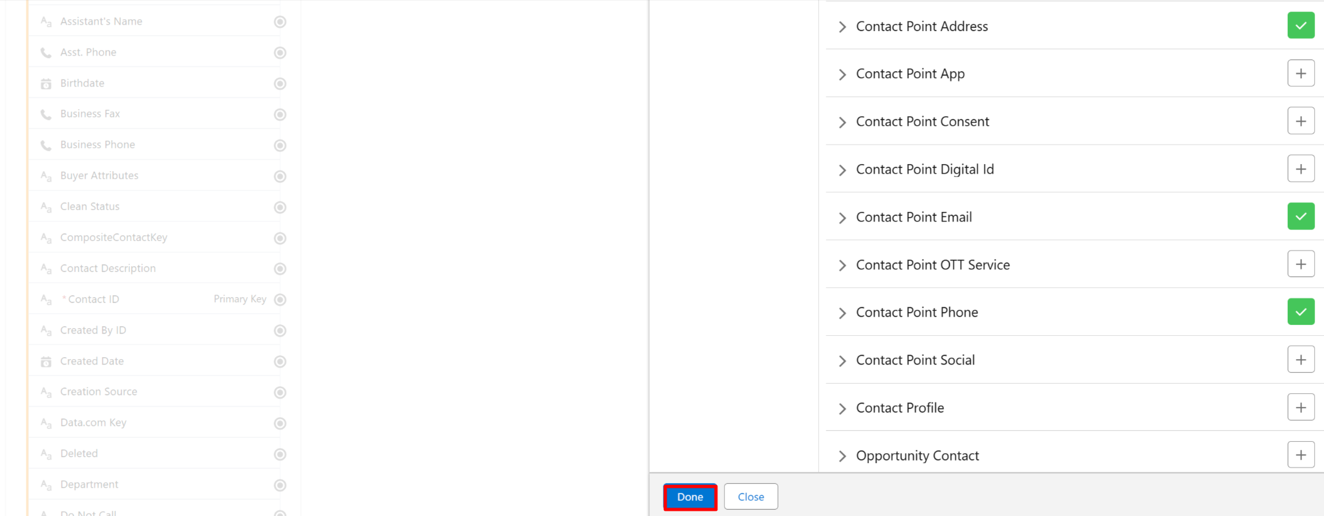

* Drag your Contact ID fIeld into the **Contact Point** **Address Id**, **Contact Point** **Email Id**, **Contact Point** **Phone Id**

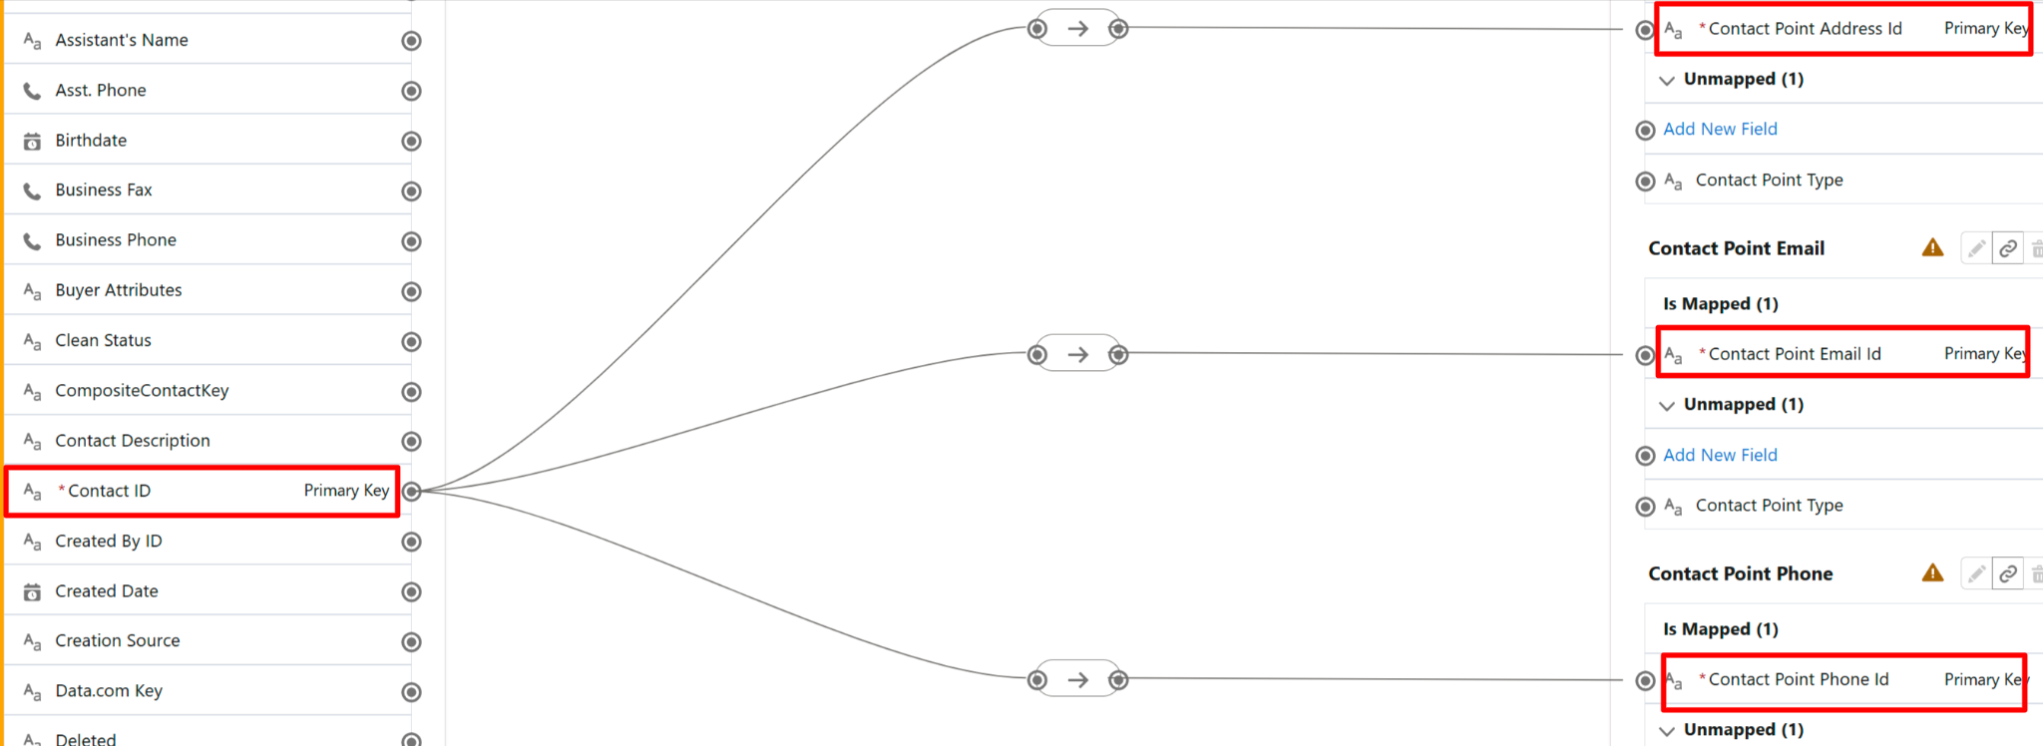

* Add New Field **Contact Point**

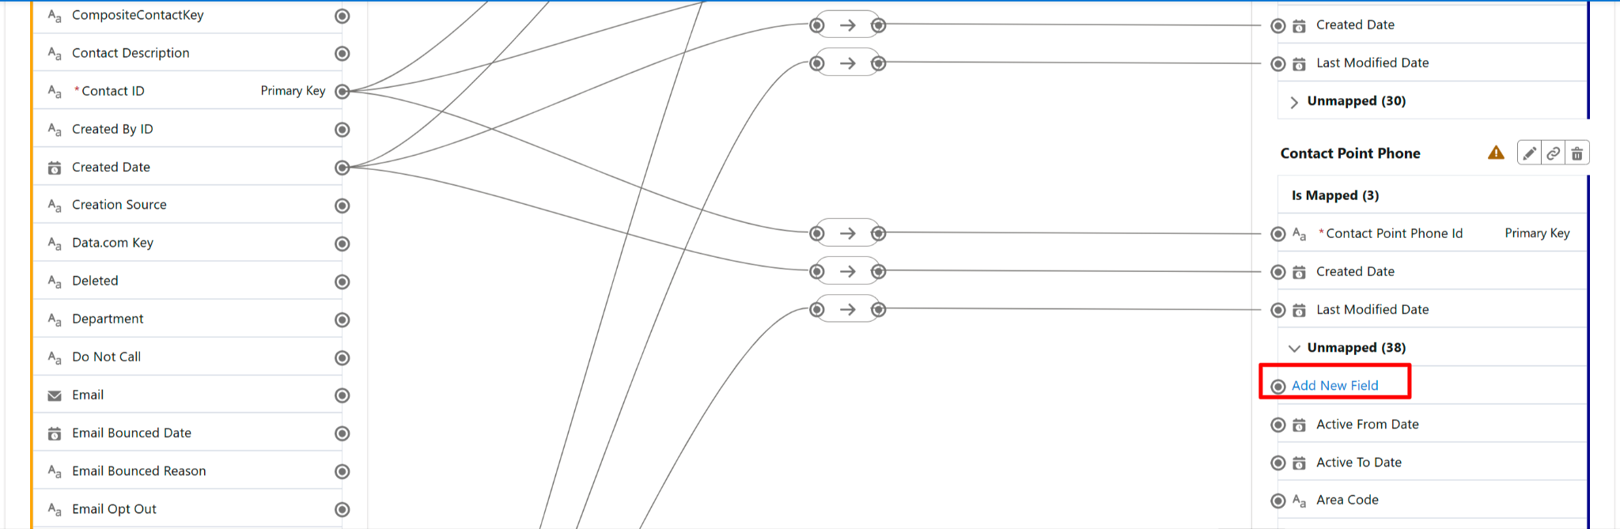

* Drag your CompositeContactKey field into the **Contact Point** section.

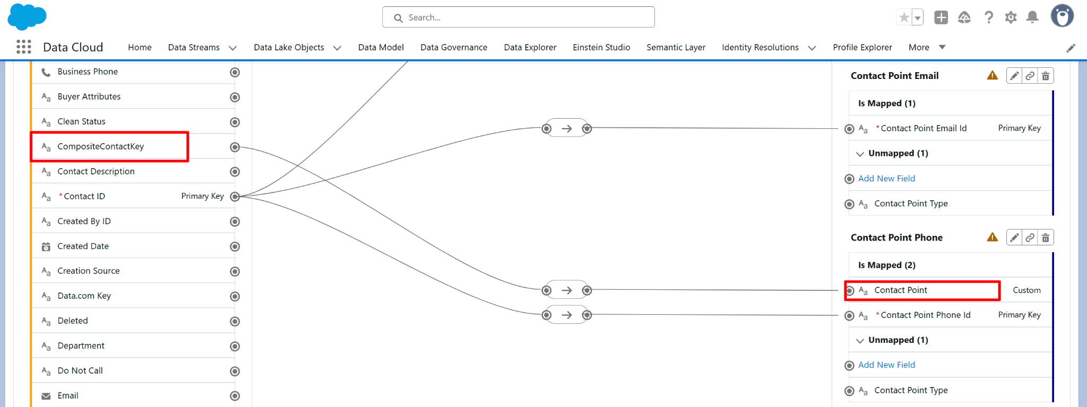

* + Now **Save & Close**.

## 

## **Part 2: Connect & Map Data**

1. **Navigate to Data Model**From App Launcher → **Data Cloud → Data Stream**.

* Select an existing data stream you ingested in Module 2 (e.g., Contact_Home).

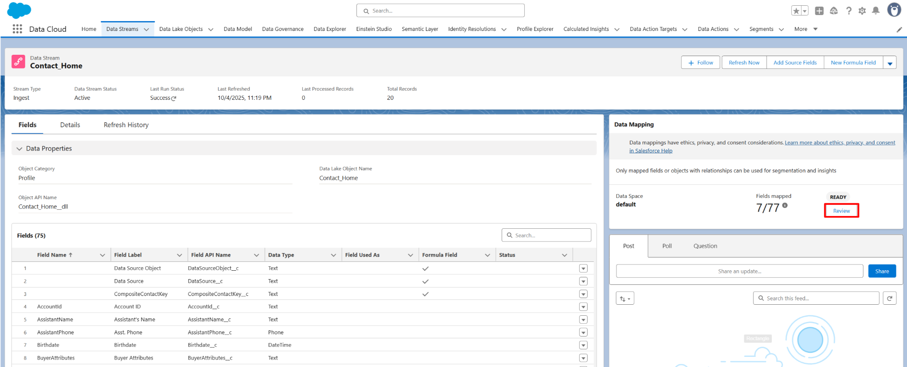

1. **Map the Data Field**

Click **Review**



The mapping interface opens. On the right side, under **Data Model entities**, expand the **Profile** subject area.

Edit **Data Model Entities.**

Click the **+** button in front of **Account Contact** and click **Done**.

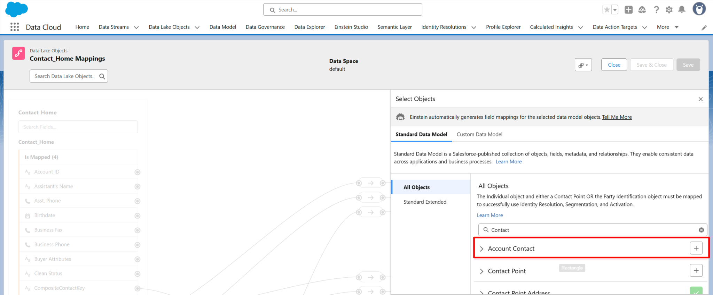

Map fields to the standard **Customer 360 DMO**:

First Name → First Name  
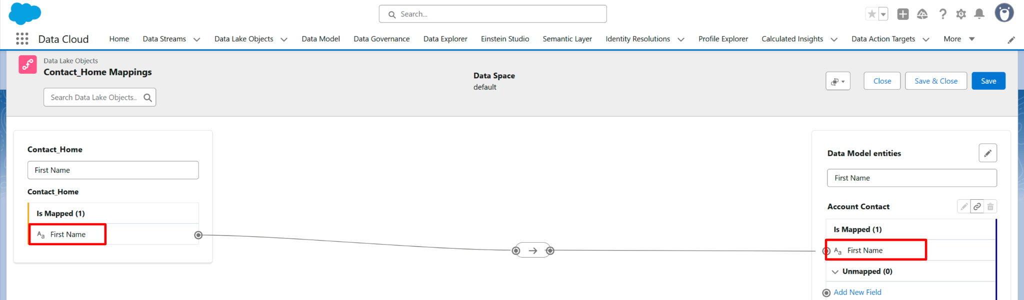

Last Name → Last Name

Email → Engagement → Contact Email

* + Ensure required fields are mapped (highlighted fields must be filled).

1. **Check Graph View**
   * Click **Graph View** to see relationships.
   * Confirm **DLO** correctly links with **DMO**.
   * Verify your formula field mapping is included.

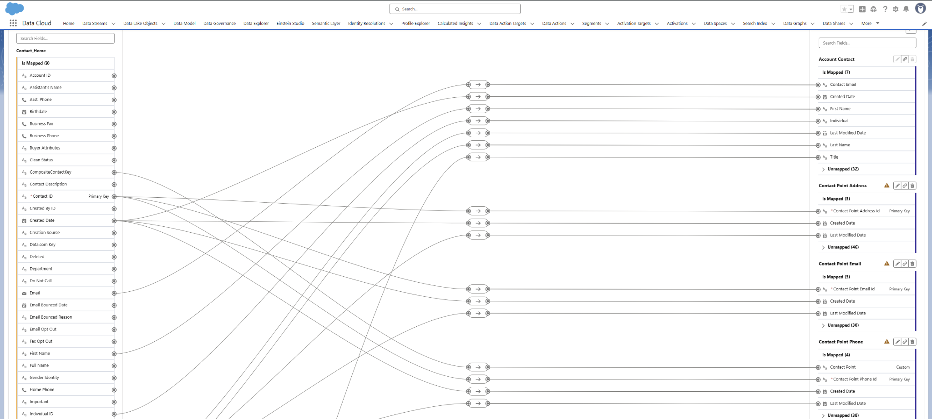

## **Part 3: Validate in Data Explorer**

### **Verify the Mapping**

1. Go back to the **Data Model**.
2. You’ll now see your **DMO (e.g., Contact Point Email)** showing the Data Stream name.
3. That confirms your mapping is live.

